Ideation Phase

Define the Problem Statements

|  |  |
| --- | --- |
| Date | 9 October 2022 |
| Team member | 142219205045,142219205011,1422192005,1422192017 |
| Project Name | Smart farmer - IOT Enabled Smart Farming Application |

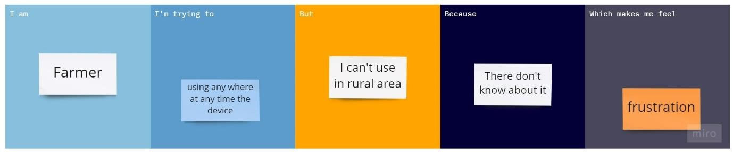

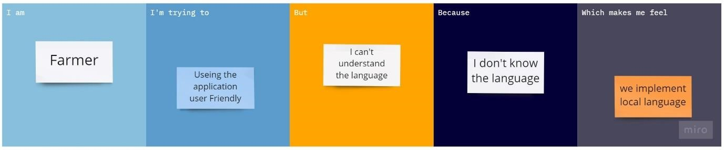

|  |  |  |  |  |  |
| --- | --- | --- | --- | --- | --- |
| Problem  Statement (PS) | I am  (Customer) | I’m trying to | But | Because | Which makes me feel |
| PS-1 | Farmer | Use this IOT device | I can’t | I don’t know how to use | Feel bad |
| PS-2 | Farmer | Use the application | It was hard | I don’t know the language | frustration |